Lab 11 Stencil buffer

1. Create an application that creates a similar reflection to that discussed in the lecture.  
   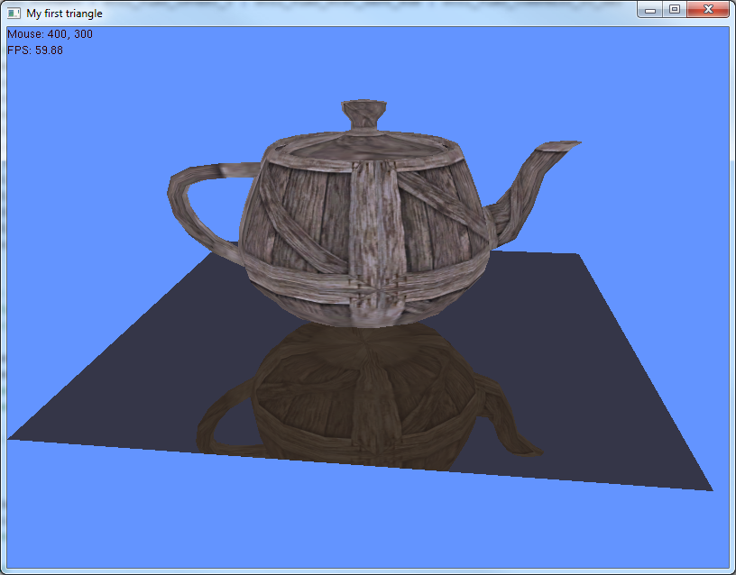
2. Change the orientation of the mirror/floor/reflective object and update your code to create a working reflection. Change the orientation to the reflective surface to be a wall and render/reflection multiple objects.
3. Use any remaining lab time to further investigate reflections, catch up on lab work or work coursework.